Parish of Georgeham
Housing Needs Report

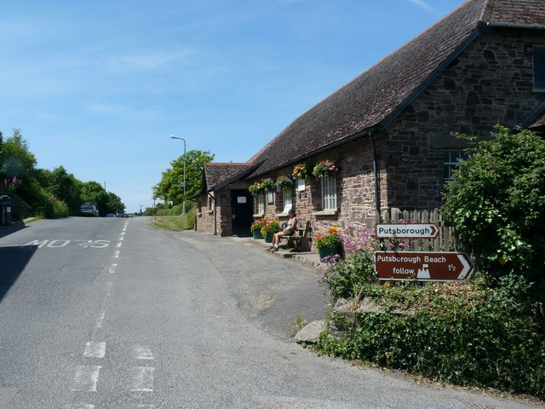

Produced by: Devon Communities Together

On behalf of: Georgeham Parish Council

Date May 2019




Contents

- Executive Summary

- Aims of the Survey

- Survey History, Methodology and Response

- Introduction and Information about Georgeham

- General Survey Findings

- Housing Aspirations of Older People

- Assessment of those wishing to move home within next 5 years

- Assessment of those in need of affordable housing

- Conclusions – Future Housing Need for Georgeham

Please note that this document is the intellectual property of the Devon Rural Housing Partnership. If this document is used by any organisation to support a development then a fee will be charged. Details of this fee can be obtained from the Rural Housing Enabler at Devon Communities Together.

Devon Communities Together
First Floor, 3 & 4 Cranmere Court
Lustleigh Close
Matford Business Park,
Exeter. EX2 8PW
Tel 01392 248919

www.devoncommunities.org.uk

1 Executive Summary

Principal Conclusions

The survey identified a need for 18 affordable homes within the next 5 years.

Key findings

Affordability

- The survey found 14 households in housing need who could not afford to buy or rent in the open market.
- 4 additional replies were received by households on Devon Home Choice who had not completed the survey but were eligible for affordable housing in the parish.

Tenure

- 13 of the households in need qualified for affordable housing for rent
- 5 may be able to afford a shared ownership or other form of low cost home ownership property.

Size of Property Required

- 14 x 1 or 2 bedroom properties for single people / couples. 2 bedroomed is preferable, providing greater flexibility, and under-occupancy by one bedroom is permitted in rural areas.
- 4 x 2 bedroom 4 person property for a family

Other Findings

- The survey achieved its aim of identifying actual households in need. 987 surveys were delivered and 213 survey forms were returned. The response rate was 22%.
- 24 Part 3 forms were returned which indicated a need to move home within the next 5 years.
  - 76% of those who answered the question said they would be in favour of a small development of affordable housing for local people. 49 households did not answer this question.
  - The Part 2 survey of older people identified households who want to move within Georgeham parish within the next five years. The preference for many of these was for smaller, more manageable homes, not specifically designed for older people. Only two of these required affordable homes, the others being owner-occupiers.

2. Aims of the Survey

- To investigate the housing need, tenure and size of homes required for local people living or working in the parish and those wishing to return.
- To establish the general level of support for new homes in the parish with an emphasis on homes for local people with housing needs.
- To establish the views of the whole community on future housing in the parish.
- To assist the Parish Council and District Council with future planning for the parish.

3. Survey history, methodology and response

3.1 History
Georgeham Parish Council decided to carry out a survey to assess future local housing need. The Rural Housing Enabler met with a representative from the Parish Council and it was agreed to proceed with the survey. Survey forms were finalised and 987 forms were hand delivered to every known household in the parish. Parishioners were able to return the survey in a reply paid envelope. The deadline for the return of the survey was 22nd April 2019.

3.2 Methodology
The survey was carried out using a standard methodology approved by local planners. Background notes on the methodology can be obtained from the Rural Housing Enabler.

The survey form was in 3 parts. The first section asked a limited number of questions about the type of household and their support for affordable housing. All residents were invited to respond to this part of the survey. The second section was aimed at parishioners aged over 55 to gauge the specific needs of older residents. The third part of the survey was designed to be completed by households who intend to move home within the next 5 years and wish to remain living in the parish. Both those who have an affordable housing need and those who wish to buy on the open market were invited to complete this section of the form. A reminder was also sent to those on the Devon Home Choice register who did not complete a survey form.

3.3 Response
- 213 surveys were returned, which is a response rate of 22% of all dwellings surveyed. Is this a good or bad response rate? Might be good to point out here as to whether the information is a good sample. This is a fairly good response rate, the average is usually around 25% and the replies includes a good cross section of the community.

- The survey achieved its aim of identifying actual households in need. Out of the 213 returned surveys, 24 were returned with Part 3 completed.

It should be noted that whilst apparent inconsistencies in responses are followed up, the information given is taken at face value.

4. Introduction and Information about Georgeham

4.1 Overview of Georgeham
Georgeham is a small parish on the North Devon coast lying in the North Devon Area of Outstanding Natural Beauty. It is located approximately 8 miles north west of Barnstaple.
The parish consists of the largest settlement of Croyde, the villages of Putsborough and Georgeham and the smaller hamlet of North Buckland. The parish is a very popular holiday and tourist destination due to its beaches at Croyde and Putsborough with a large holiday park being located in Croyde and many other campsites, caravan parks and holiday properties located in the area. There is also a National Trust site at Baggy Point.

The parish has many amenities spread through the 4 settlements. There is a parish church (Georgeham village), 2 village halls (Georgeham village and Croyde), primary and pre-school (Croyde), a village shop (Georgeham village), Post Office (Croyde) playground area (Georgeham village) and several public houses. There are also many cafes, restaurants, B & Bs and gift shops serving the tourist trade, especially the surfing fraternity, who visit the area for the good surf conditions. Obviously many of these latter amenities are seasonal with most employment in the parish also being seasonal to meet tourist demand. A mobile library visits Croyde and Georgeham village once a month.

Local clubs and groups include WI, football team and drama group.There is a regular deckchair cinema at Croyde Village Hall as well as Yoga classes at Georgeham and Croyde village halls, drama group.

Possibly due to its status as a tourist destination, there is a regular bus service in the parish which links Georgeham and Croyde to Barnstaple and Ilfracombe. Road links are good with the A361 road linking the parish to Barnstaple and then further into Devon.

4.2 Population Figures
In the 2011 census the usually resident population of Georgeham was recorded as 1440 in 1053 households. The census also records that there were 433 dwellings which were empty properties, second homes or holiday lets. This is 41% of the total number of households which reflects the nature of the area as a holiday destination.

4.3 Type of Accommodation
In the 2011 Census the types of accommodation in the parish was broken down as in Table 1 below. The largest category by far is detached houses or bungalows. There are very few terraced houses or flats.

Table 1
Detached  house/bungalow | Semi-detached house/bungalow | Terraced  house/bungalow | Flat | Caravan / mobile home | Total
444 | 92 | 39 | 40 | 5 | 620

4.4 Bedroom numbers
In the 2011 Census the number of bedrooms per dwelling was broken down as in Table 2 below. The vast majority of homes have between 3 and 4 bedrooms with very few smaller 1 bedroom properties.

Table 2
1 bedroom | 2 bedrooms | 3 bedrooms | 4 bedrooms | 5 or more | Total
25 | 132 | 226 | 152 | 84 | 620

When viewed together these tables show that there is a lack of smaller, cheaper accommodation in the parish with detached dwellings and properties of 3 bedrooms plus being the most prolific. Therefore there are very few properties suitable for those on low incomes to buy or rent.

4.5 Property Prices and Rent
In the last 2 years the Land Registry has recorded 57 property sales in the parish. The average price of properties was £512,000. Prices ranged from £160,000 for a one bedroom terraced house to £1,150,000 for a 5 bedroom detached house.

There are currently 20 property listings in the parish on the Rightmove website. 4 of these are in Georgeham village and 16 in Croyde. The cheapest house on the market at the moment is a 2 bedroom property for £350,000. There are only 3 houses for sale under £400,000.

To assess whether a household can afford to buy in the open market it is necessary to look at the cost of an entry level property in the local market. This is done by comparing information on recent house sales and homes currently on the open market. Average rents are identified by comparing local private rents gained from the housing need survey with rents of properties currently on the market. From this information, we can establish typical rents to assess affordability. There were no one bedroom properties for rent on the open market at the time of writing this report therefore data has been taken from surrounding rural areas.

The figures used to assess affordability are set out in Table 3 below.

Table 3
Size | Property price | Weekly rent
1 bedroom | £160,000 | £130
2 bedroom | £300,000 | £160
3 bedroom | £350,000 | £180

There are currently 30 affordable homes in Georgeham Parish. Details are broken down in table 4 below.

Size | Rented | Shared Ownership | Discount sale | Total
1 bedroom | 8 | 0 | 0 | 8
2 bedroom | 12 | 0 | 0 | 12
3 bedroom | 7 | 1 | 1 | 9
4 bedroom | 1 | 0 | 0 | 1
Total | 28 | 1 | 1 | 30

None have been let in the last 2 years. Therefore lettings of current affordable housing stock will have little impact on future need figures.

5. General Survey Findings

5.1 In favour of a small local development
Respondents were asked if they would be in favour of a small number of homes for local people being built if the need for affordable housing were proven. 76% of those answering the question said they would be in favour. 24% said they were against any development. It should be noted that 49 households did not respond to this question. Fig.1 below shows the breakdown.

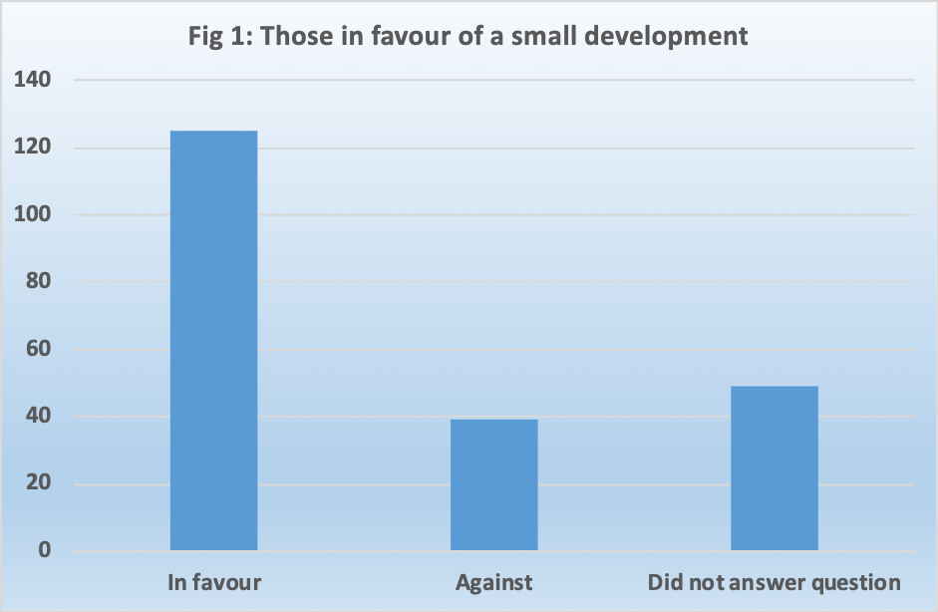

5.2 Site suggestions and general comments
56 individuals made suggestions for possible housing sites within the parish and made more general comments about housing in the parish. These suggestions and comments will be made available to the Parish Council on a separate document.

5.3 Knowledge of those who have left parish in last 5 years
Respondents were asked if they knew of anybody who had had to leave the parish in the last 5 years due to lack of suitable housing.

- 44 households replied that they did know of someone

5.4 Current tenure
Of the 196 respondents who provided details, 159 (81%) own their own home, 23 (12%) rent from a private landlord and 8 (4%) live with relatives. The remaining 6 households (3%) are made up of 3 who rent from a housing association and 3 who live in housing tied to their job. Figure 2 below shows the breakdown of tenure.

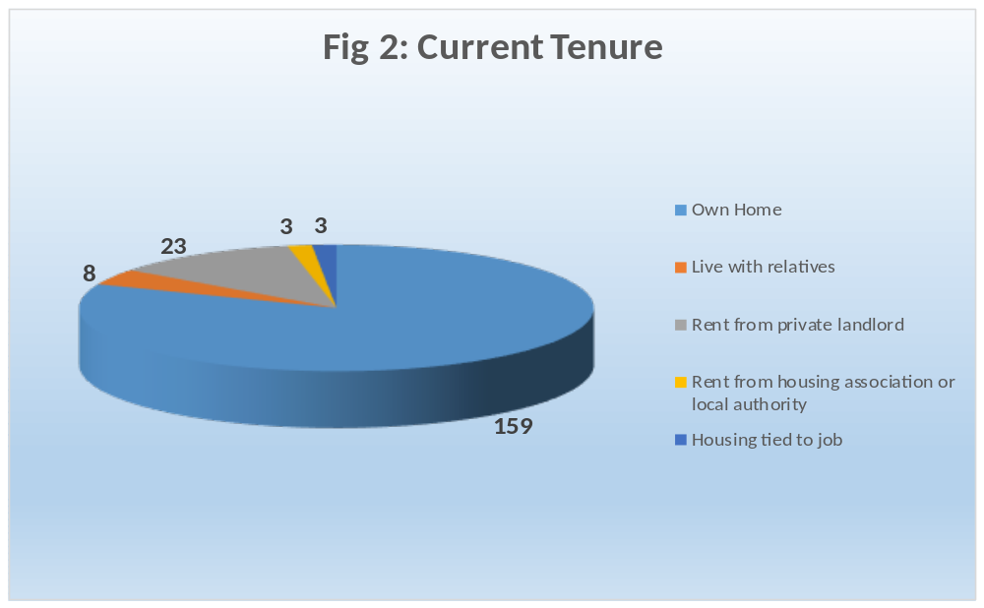
5.5 Main or second home
25 of the respondents were second home owners. This is a high proportion compared to other housing need surveys and illustrates the high number of holiday and second homes there are in the parish.

5.6 Parish of Residence
Respondents were asked which parish they lived in. All but 4 of the respondents live in Georgeham parish (including Croyde). Of the other 4, 1 lives in Braunton, 1 in Nuneaton, 1 in Tetbury and 1 was illegible.

5.7 Number of bedrooms in current home
Respondents were asked how many bedrooms their current home has. The replies are shown in Table 5 below.

Table 5
Number of bedrooms | 1 | 2 | 3 | 4+
Respondents | 33 | 35 | 62 | 81

5.8 Future plans
Respondents were asked whether they intended to move home within the next 5 years. If they answered Yes to this question they were asked to complete Part 3 of the form.

- 27 households stated they did intend to move within the next 5 years

5.9 Community Land Trusts (CLTs)
Respondents were asked whether they would consider becoming a member of a CLT.

- 13 households showed an interest and 12 of these left contact details.

- Housing needs and aspirations of older residents

Part 2 of the questionnaire was directed at residents over the age of 55. The number of people over the age of 55 is set to rise significantly across the UK over the next 20 years. In 2014 the Office for National Statistics published population projections for the next 20 years. These figures show that by 2034 the percentage of people over the age of 55 will have increased by 23% across Devon and by 25% in North Devon during that period.

205 people answered Part 2 of the survey from 130 households with at least one member over the age of 55. This is 61% of the total respondents.

6.1 Age of Respondents to Part 2 survey
Respondents were asked to give their age in 10 year bands. As can be seen in Table 6 below, the majority of those who replied (79%) were aged between 55 and 75.

Table 6
Age Group | 55-65 | 66-75 | 76–85 | Over 85
Number | 96 | 66 | 35 | 8

6.2 Future Housing Plans
Households were asked about their future housing plans.

- 20 households plan to move within the next five years. Of these, 10 would like to remain in Georgeham.
- 2 of these 10 households may need affordable housing.
- 15 further households expect to move after five years.
- 91 have no plans to move at the moment.
- 4 households did not answer the question.

6.3 Adaptability of current home
Respondents were asked if their current home was adaptable to meet changing needs.

- 87 did believe their current home was adaptable
- 33 did not believe their current home was adaptable

6.4 Type of Accommodation preferred by older persons
Older households were asked what type of accommodation they may need in the future. The majority preferred a home better suited to their needs but not designed for older people. Preferences are shown in Table 7 below.

Table 7
Type of Accommodation Preferred by Older Persons | Number
Home better suited to needs but not specifically designed for older people | 23
Home specially designed for older people | 10
Residential / nursing home | 4

6.5 Considerations when choosing next home
Households were asked to list the most important considerations when choosing a new home.
They could give more than one reason. The reasons are listed below in Table 8.

Table 8
Most important consideration | Number
Need to downsize to a smaller more manageable home | 19
Proximity to shops/amenities | 17
Proximity to public transport | 15
Cheaper running costs | 13
Need to be near family / carers | 12
Need one level for medical reasons | 10

The two most important considerations were that older persons wished to move to a smaller property that was closer to shops and amenities.

6.6 Conclusion – Older Persons Needs
The older persons’ survey shows that the majority of households (70%) have no plans to move home. However, the parish does have a number of older households who wish to downsize to smaller accommodation that is easier to maintain, has lower running costs and is close to amenities and support.

Only 2 of the 10 households that expect to move home within the next 5 years and remain in Georgeham believe they will need affordable housing. The remaining 8 households would require open market housing. Small open market bungalows, flats and houses can be built, however, developers who build open market homes do not usually attach any kind of local connection covenant as this reduces the value of the homes. This means that any open market properties cannot be guaranteed for local people.

Meeting the housing needs of this group of people should be given further consideration.

- Assessment of those wishing to move to a new home in
Georgeham within the next 5 years

Part 3 of the survey was aimed at those who expect to need to move home within the next 5 years and remain in Georgeham. It asked questions regarding size and make-up of the new household, local connection and financial circumstances. This information helps to identify the number of households that are eligible for both open market and affordable housing in the parish and the size, tenure and type of homes required.

27 households indicated a need to move within the next 5 years and remain in Georgeham, however only 24 completed Part 3 of the survey. The needs of these 24 households have been included in this section of the survey.

7.1 Minimum bedroom requirement
Respondents were asked the minimum number of bedrooms they would require in their new home. Table 9 below shows the breakdown. It should be noted that there are criteria relating to affordable housing that set the number of bedrooms that a household are eligible for based on the number of adults and children in that household.
Table 9
1 bedroom | 2 bedroom | 3 bedroom | 4 bedroom | 5 bedroom
1 | 18 | 2 | 1 | 1

7.2 Timescales for moving
Households completing this part of the form were asked to identify when they would need to move.

- 3 households indicated a current need to move.
- 2 households indicated a need to move within the next 1-3 years.
- 3 households indicated a need to move within the next 3 - 5 years.
- 4 households did not answer the question

7.3 Housing tenure
Respondents were asked what type of accommodation they would consider moving to. This gives an indication of respondents’ aspirations rather than confirming which type of housing they are eligible for. The results are shown in table 10 below. Respondents could choose more than one option.

Table 10
Shared ownership/ equity | Affordable housing for rent | Self-build | Discount market | Rent to buy | Open market
11 | 10 | 5 | 9 | 11 | 7

7.4 Reasons for moving
Respondents were asked why they wished to move home. They could tick more than one box.

Table 11 shows why households need to move

Table 11
Reason for wishing to move | No of respondents
Will be leaving home and do not expect to be able to rent or buy privately | 7
Wish to move back to the parish and have a strong local connection | 4
Private tenancy ending | 3
Need to downsize to a home with fewer bedrooms | 2
Need to move for health/mobility reasons | 2
Struggling to afford current home | 2
Need to move to a home with more bedrooms | 2
Sharing facilities with someone who won’t be moving with you | 1
Need to move for work | 1
Home is in poor condition | 1
Other (want to buy own home, want to live near parents, no security renting) | 4

7.5 Budget for new home
Respondents who wished to purchase a home were asked about their budget. Table 12 below shows the breakdown of replies.

Table 12
Less than £!50,000 | £150,000 - £200,000 | £200,000 - £250,000 | £250,000 - £300,000 | £350,000+
1 | 12 | 3 | 1 | 1

8. Assessment of those in affordable housing need
This section of the survey looks at the number of households who would qualify for an affordable home in the parish, based on their household income and savings.

8.1 Exclusions
All 24 of the households who completed Part 3 of the form have been assessed and 6 have been excluded for the following reasons:-

- 2 could afford to buy on the open market
- 1 gave insufficient details to assess their eligibility
- 3 already own their own home and want to buy an open market property so do not qualify for affordable housing.

This leaves 18 who would qualify for affordable housing.

8.2 Local Connection
In order to qualify for affordable housing, respondents must have a local connection to the Parish. This connection is determined by North Devon Council and is set out below:-

(a) at least one adult in the household was resident continuously in the Parish for a
minimum of five years immediately prior to occupation;
(b) at least one adult of the household was resident in the Parish for five years within
the previous ten years immediately prior to occupation;
(c) at least one parent, guardian, child or sibling of at least one adult in the household,
has been resident in the parish for a minimum of 5 years immediately prior to
occupation; or
(d) at least one adult in the household has been in continuous employment for at least
16 hours a week in the parish for at least five years immediately prior to occupation.

4 of the respondents do not have this connection at this moment in time. This leaves 14 households who may qualify for affordable housing and have a local connection to Georgeham parish.

8.3 Preferred housing tenure
The survey also asked households who had a housing need which tenure of housing they were interested in. Respondents could give more than one option. The responses are listed in Table 13 below.

Table 13
Type of housing | Interested
Shared ownership/equity | 9
Affordable housing for rent | 7
Self-build | 3
Discounted market sale | 6
Rent to buy | 9

8.4 Housing Options
The housing options available to the 18 households in need are now given consideration.

Respondents provided information on income and savings which allows an assessment of what the household can afford to pay for their accommodation. These incomes are shown in Figure 3 below.

Given the financial circumstances of the households in need, 5 may be able to afford a shared ownership home or other low cost home ownership tenure but the other 9 would require affordable housing for rent.

8.5 Other evidence of housing need
As well as this survey other evidence of housing need should be considered. The housing waiting list or register for Devon is called Devon Home Choice. Applicants are given a banding from A to E depending on their level of need. There are 21 households resident in the parish registered on Devon Home Choice. Details are set out below.

Table 14
Devon Home Choice band | 1 bed | 2 bed | 3 bed | 4 bed | Total
Band A (Emergency need) | 0 | 0 | 0 | 0 | 0
Band B (High) | 0 | 0 | 0 | 0 | 0
Band C (Medium) | 0 | 2 | 0 | 1 | 3
Band D (Low) | 4 | 0 | 0 | 0 | 4
Band E (No Housing Need) | 10 | 3 | 1 | 0 | 14
Total | 14 | 5 | 1 | 1 | 21

Only 6 of the households who are registered on Devon Home Choice completed the survey. Due to this apparent disparity, all those who are registered with Devon Home Choice and living within the parish were contacted separately by letter and a further 5 replies were received. 4 of these did want affordable housing in the parish and met the local connection. These 4 have been added to the final numbers, giving a total need of 15.

8.6 Housing Mix
The suggested mix of housing is shown in Table 15 below. This takes account of the family makeup as declared on the survey form and the type of housing required.

Table 15
Type of Property | Affordable Housing for Rent | Shared Ownership | Totals
1 or 2 bedroom property for single people | 7 | 4 | 11
1 or 2 bedroom property for couples | 2 | 1 | 3
2 bedroom property for families | 4 | 0 | 4
Totals | 10 | 5 | 18

1 household requires a property with level access.

9. Conclusion - Future Housing Need for Georgeham

Overall, it must be remembered that this Housing Needs Survey represents a snapshot in time. Personal circumstances are constantly evolving. Any provision of affordable housing would, by necessity, need to take account of this. However, given the level of response to the survey, and in spite of the potential for circumstances to change, the Parish Council can feel confident in the results of this survey. The survey has identified a need in the near future for 18 units of affordable housing.

Any further action taken towards meeting this housing need will require the support of the Parish Council and wider community consultation. Should the Parish Council wish to address the identified housing need, the Rural Housing Enablers are available to help identify potential sites, conduct site appraisals and facilitate the process of identifying potential development partners as well as any other ongoing assistance that may be required.

As the needs of households are constantly evolving the level and mix of need in this report should be taken as a guide. In particular it may be appropriate to vary the mix of sizes provided. This report remains appropriate evidence of need for up to five years. However if there is a significant development of affordable housing in the parish which is subject to a local connection requirement and substantially meets the need identified in the report it will normally be necessary to re-survey the parish before any further development to address local needs is considered.

Recommendation

It is recommended that the Parish Council:

- Note this report
- Consider the options for addressing the need for 18 affordable homes. An Option Appraisal will be provided by the RHE as a separate document.

Front cover photo © Copyright Roger A Smith and licensed for reuse under this Creative Commons Licence.

These tables only give details for 620 dwellings, this is because there is no data for empty homes in this dataset.
Data correct as of 29/4/19

